Medical Front Office Assistant Certificate Information Session

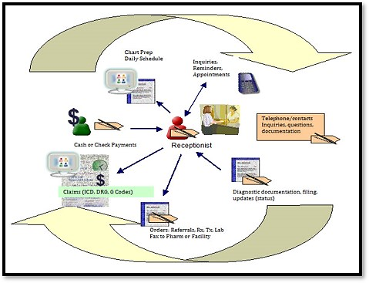
- This session is meant to be reviewed alongside the information packet for the program.
- If you have not printed it or do not have the packet open in another window on your computer, please stop and have that information in hand before continuing.
- Medical Front Office Information Packet.

Medical Front Office at a Glance
- Special skills are necessary for handling a busy and demanding medical office. Medical front office assistants work in clinics and hospitals, doctors’ offices, medical insurance companies, health care organizations and more.
- Front office support professionals perform administrative duties such as dealing with incoming and outgoing patients, scheduling, and monitoring appointments, creating and maintaining patient records, applying standardized codes to patient records, and insurance billing.
- "Front office" skills allow you to work in a medical setting without direct patient contact. Instead, you will use information technology to support the “back office” medical staff, including care providers such as doctors and nurses, so that they can function efficiently.

Why is this a Good Career Bet?
- Health care reform and an aging population play a large role in the growth of all medical-related jobs.
- According to the U.S. Department of Labor, Bureau of Labor Statistics, employment of medical assistants is projected to grow 19 percent from 2019 to 2029, much faster than the average for all occupations.
- Medical assistants are listed by America’s Career Infonet as number 18 of the top 100 fastest-growing careers requiring a post-secondary certificate.

Typical job duties include
- Schedule and manage appointments.
- Checking in patients at the front desk.
- Answering and routing phone calls.
- Maintain patient charts by obtaining, recording, and updating personal and financial information.
- Perform billing and coding procedures.
- Process insurance payments.
- Operate computer software and office equipment.
- Maintain supplies and appearance for the office.
- Protect patients' rights by maintaining confidentiality of personal and financial information.

Potential employers
- Family practices.
- Medical specialist practices.
- Primary healthcare organizations.
- Long-term or extended-care settings.
- Medical insurance companies.
- Billing service organizations.
- Agencies related to healthcare.
- Surgical centers.

Possible Job Titles
- Medical Receptionist.
- Medical Office Assistant.
- Medical Administrative Office Assistant.
- Medical Front Office Support.
- Health Unit Coordinator.
- Medical Secretary.
- Medical Front Office Coordinator.

Medical Front Office Assistant Program Overview
- The mission of the Medical Front Office Assistant program is to provide a supportive environment in which students will develop the knowledge, skills, and attitudes essential for successful employment in a medical front office setting, including practices, clinics, and hospitals.
- The curriculum prepares students to work in entry-level office positions in a variety of health care settings with skills in medical terminology, medical office procedures, computer applications, medical software applications as well as basic medical billing and coding.
- Courses in this certificate are either offered as face-to-face courses at the Brookhaven campus or completely online. Please check the browsable class schedule for specific course offerings each semester.

Admission Criteria
- A high school diploma or General Education Development (G.E.D.) certificate.
- Complete an application for admission to the college.
- Establish financial resources.
- While no assessment testing is required for this level I certificate (TSI waived), it is recommended you demonstrate at least a 10th grade reading level.
- View this mandatory online information session and submit questionnaire at the end.
- Meet with program advisor for initial advising and registering for the correct sequence of classes.

Contact Information
Please contact a Success Coach for initial advising, help with course selection and registration:
Success coaches (advisors) will be available for walk-in and virtual drop-in meetings.
- Visit a Success Coaching Center
- Use virtual success coaching (advising) services
- Call 972-669-6400 or email SuccessCoach@dcccd.edu
If you have any questions regarding the program, please send a detailed email with your full name and seven-digit student ID to Nehal Rangnekar, Professor/Coordinator, Medical Front Office program, at nRangnekar@dcccd.edu.

Program Curriculum
The Medical Front Office Assistant program is offered for college credit at the Brookhaven campus and consists of the following two awards:

- Medical Front Office Assistant Occupational Skills Award (OSA)

Semester I courses- 13 college credit hours.

Medical Front Office Assistant Level I Certificate

Semester I - 13 college credit hours + Semester II – 8 college credit hours for a total of 21 college credit hours
  - Students must have completed all the courses listed under Semester I for college credit in order to enroll in Semester II classes.
  - Students must complete all courses in Semester I and II prior to enrolling in the final POFM 1280 Cooperative Education externship course. This final capstone course requires students to complete 160 hours of unpaid, practicum/externship with an approved medical facility (see information packet for more details and requirements for the externship).
Estimated Expenses
- Dallas County Residents pay $79 per credit hour ($237 per three-hour class).
- Out-of-County Residents pay $135 per credit hour ($405 per three-hour class).
- IncludED on Day One: the price of most required learning materials — including textbooks and online publisher content will be included with the price of tuition.
- If you opt out of the IncludED program, you are responsible for obtaining all your required learning materials by the first day of the class.
- This cost estimate does not include the fees for immunizations, criminal background check, or drug testing if required by the health care facility.

Financial Aid
- Determine financial needs. Apply early!
- Please call 972-669-6400 or email FinancialAid@dcccd.edu for assistance. ​
- Visit financial aid link where you can locate a variety of tools and resources and learn more about financial aid.

THANK YOU FOR VIEWING OUR ONLINE INFORMATION SESSION
- You will now be directed to complete a questionnaire over the information provided..
- An email will be sent to you as well as our staff once you have completed the questionnaire.
- Please retain this email for your records and verification that you have watched the information session.
- You may then contact a Success Coach for help with course selection and registration.
WE WISH YOU THE BEST!

