FBAIdvisory

If you receive a suspicious letter or package
What should you do?

No Return Address Restrictive Markings

Possibly Mailed from a
Foreign Country
Excessive Postage

Handle with care Don’t shake or bump
1
Isolate and look for indicators
2
Don’t Open, Smell or Taste
3
Treat it as Suspect! Call 911
4

Oily Stains, Discolorations,
Misspelled Words
Addressed to Title Only or Incorrect Title
Badly typed or written Protruding Wires
Lopsided or Uneven Rigid or Bulky
Strange Odor

Wrong Title with Name

or Crystalization on Wrapper
Excessive Tape or String

If parcel is open and/or a threat is identified. . .

For a Bomb
Evacuate Immediately Call 911 (Police) Contact local FBI
For Radiological
Limit Exposure - Don’t Handle Distance (Evacuate area) Shield yourself from object Call 911 (Police)
Contact local FBI
For Biological or Chemical
Isolate - Don’t Handle Call 911 (Police)
Wash your hands with soap and warm water Contact local FBI

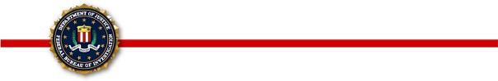
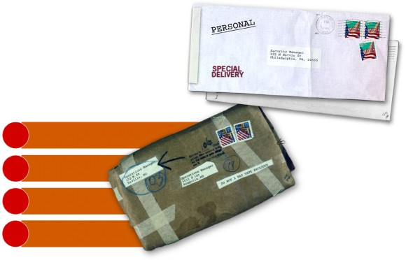

Police Department Fire Department Local FBI Office
(Ask for the Duty Agent, Special Agent Bomb Technician, or Weapons of Mass Destruction Coordinator)

GENERAL INFORMATION BULLETIN 2000-3
Produced by: Bomb Data Center
Weapons of Mass Destruction Operations Unit

