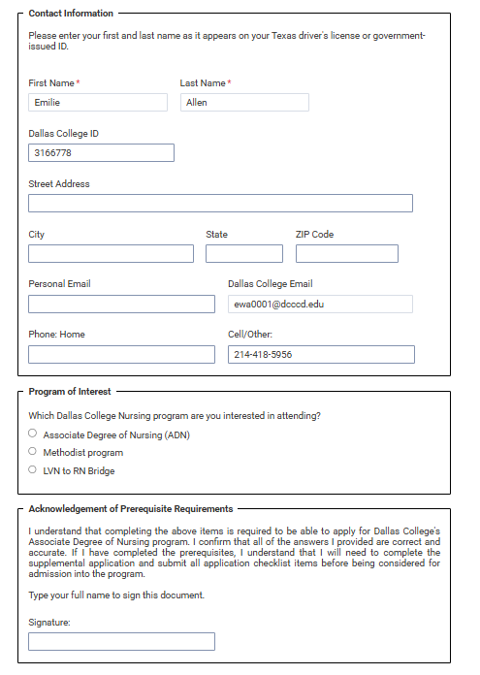

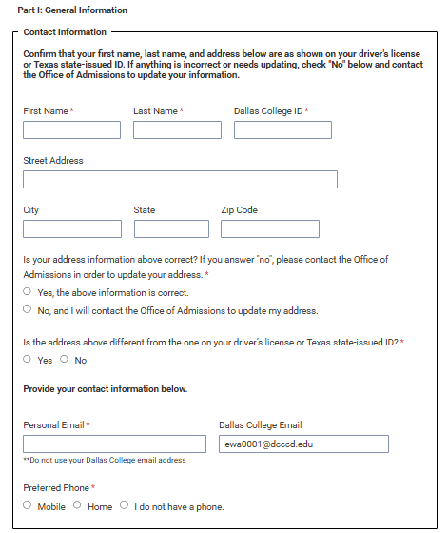
Your personal email address is required. It may not be any form of a Dallas College email.
NOTE: There will be an option to enter a corrected address if needed
NOTE: The name you enter must match your Texas ID exactly

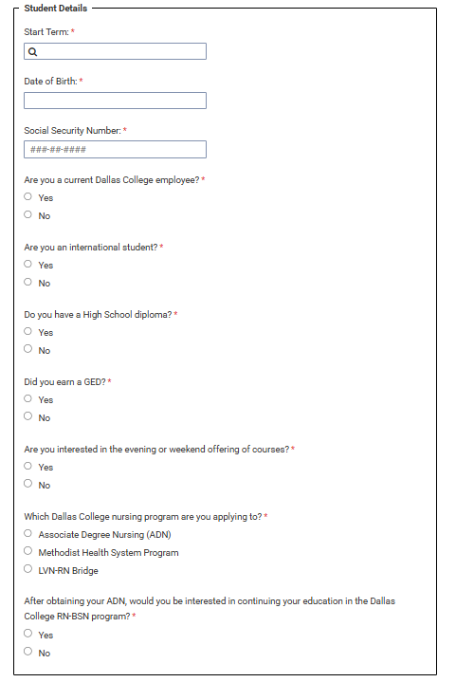
These courses will only be offered at the Brookhaven, Mountain View, and North Lake
(as enrollment allows)
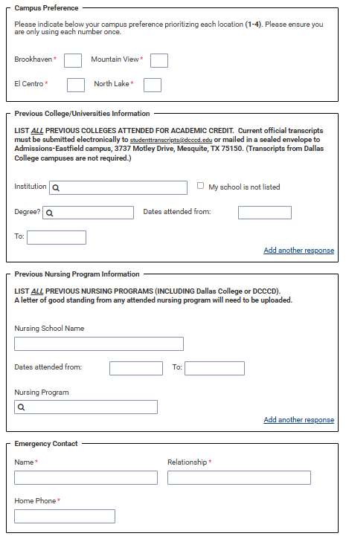Complete the Acknowledgement questions on the application.
If you attended a nursing school other than Dallas College, a Letter of Good Standing will need to be obtained and uploaded where indicated.
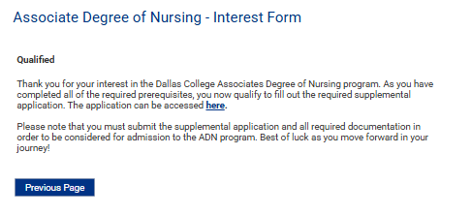
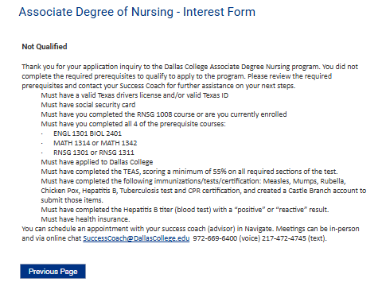
When you receive the link to the application, follow these instructions:

When you receive the link to the application, follow these instructions:
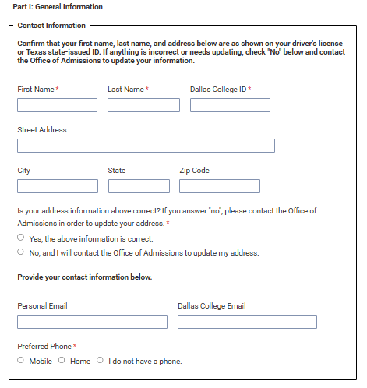
A personal email address is required. It cannot be a Dallas College email address of any kind.
This information will be auto filled with your Dallas College account information.
If the information matches what is on your TX ID, click “yes”. If it does not, click “no” and contact the office of admissions to make any corrections.
If this information matches your TX ID, click yes. If it does not, click no and contact admissions to update any information that is not accurate.

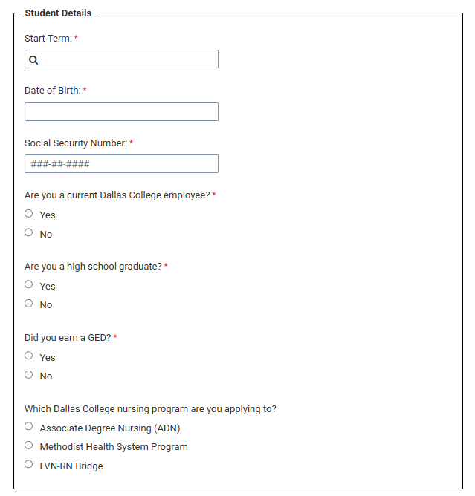
This question is asking if you have a high school diploma.
You will need to add the dashes to the number
This selection will determine the documents and information you must upload after your application submission.

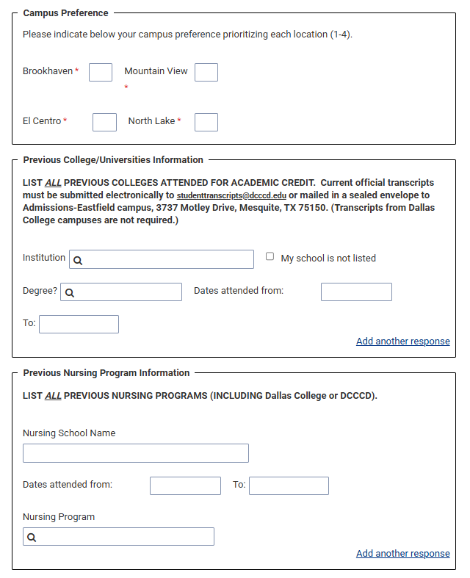
If you have attended another nursing program, a Letter of Good Standing from that institution is required. You will upload the letter in the student hub.
You will rank your campus preference with 1 being your 1st choice and 4 being your last choice.

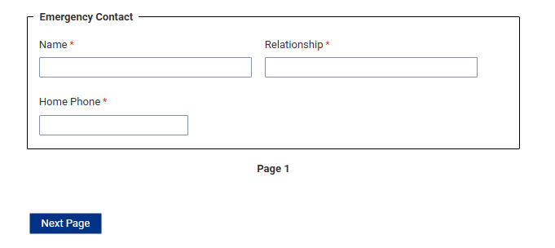
This can be a cell phone if a home phone is not available.
Acknowledgements Page:
Check each Acknowledge box to verify that you have read and understand this information
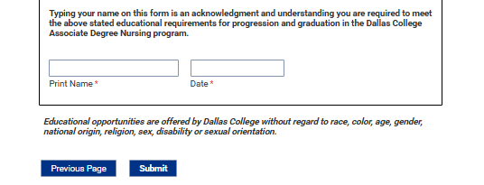
Print your name, enter the date and click “Submit”

Student Connection Hub Login - Nursing
The new workflow process for the Nursing Program aims to streamline and enhance the student enrollment experience by capturing essential student information through the Student Connection Hub. This process is designed to ensure all required data is collected seamlessly and securely. To access the Student Connection Hub, please follow the instructions listed below.
STEP: 2. Click on the Student Connection Hub Link “here” in the “Your Application has been Received” email.
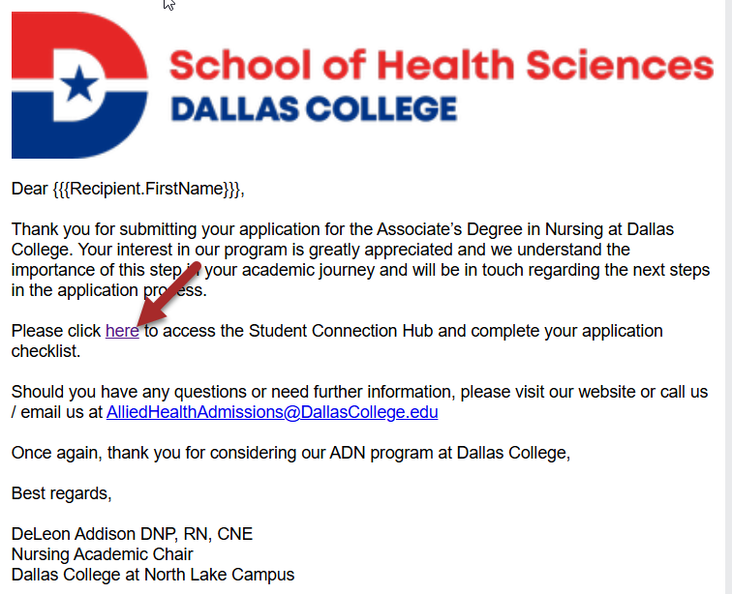
STEP: 3. Click on the Dallas College Microsoft SSO button.
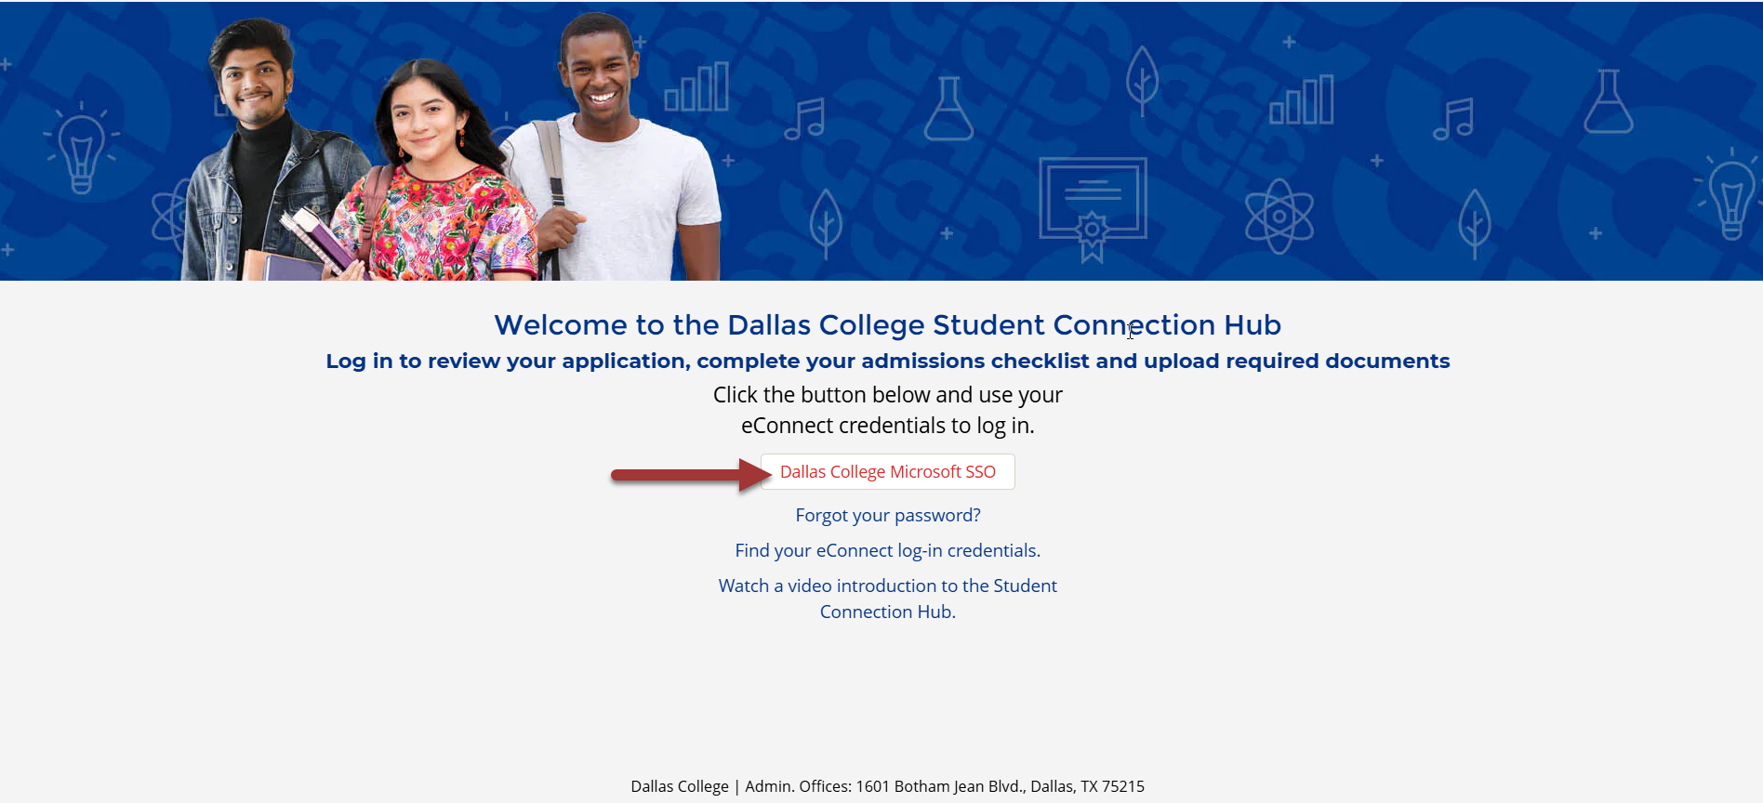
STEP 4. Enter your Dallas College email, and click Next.
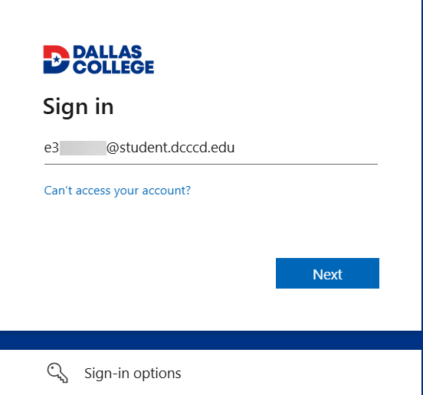

STEP 5. Enter your Dallas College Password, and click Sign In.
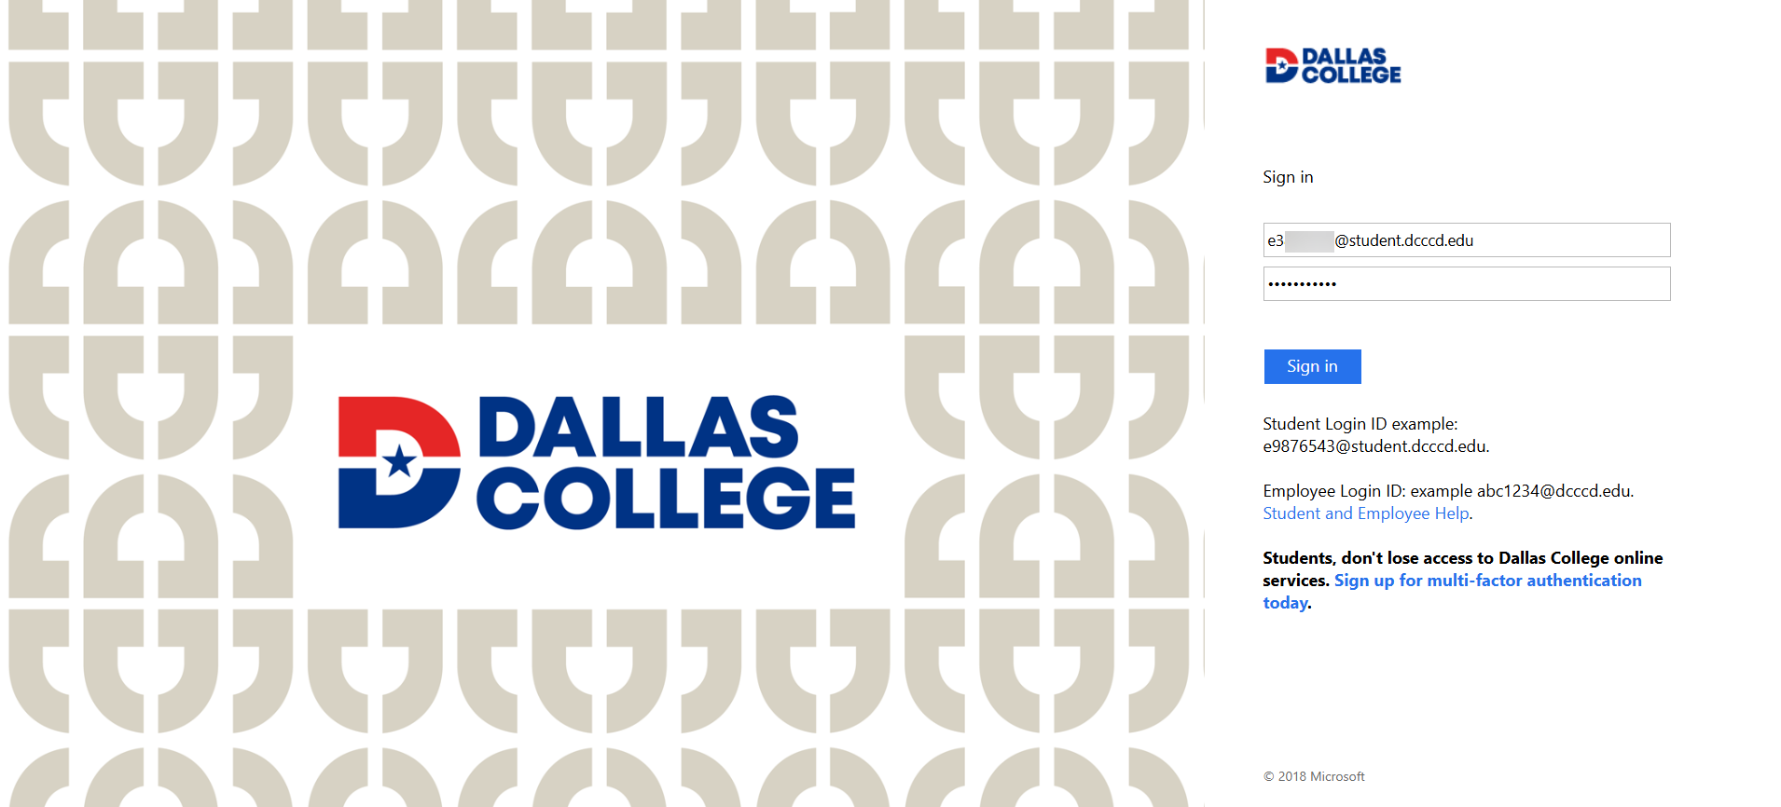

STEP 6. Select how you want to Verify your identity through text or call.
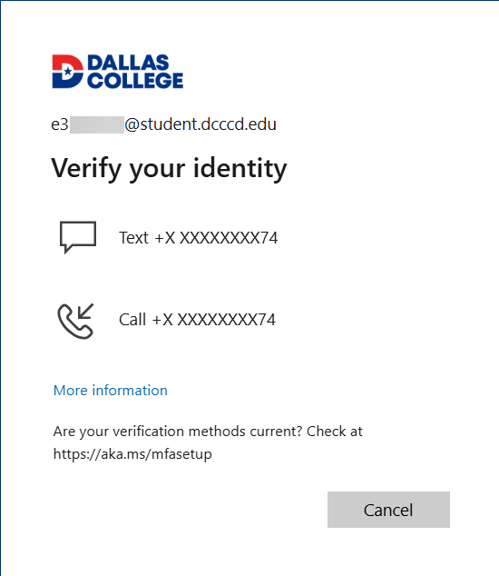
STEP 7. Enter your Code, and click Verify.
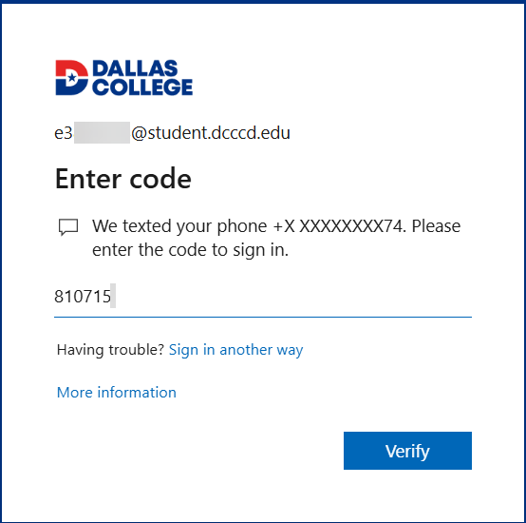

STEP 8. Click on My Application tile.
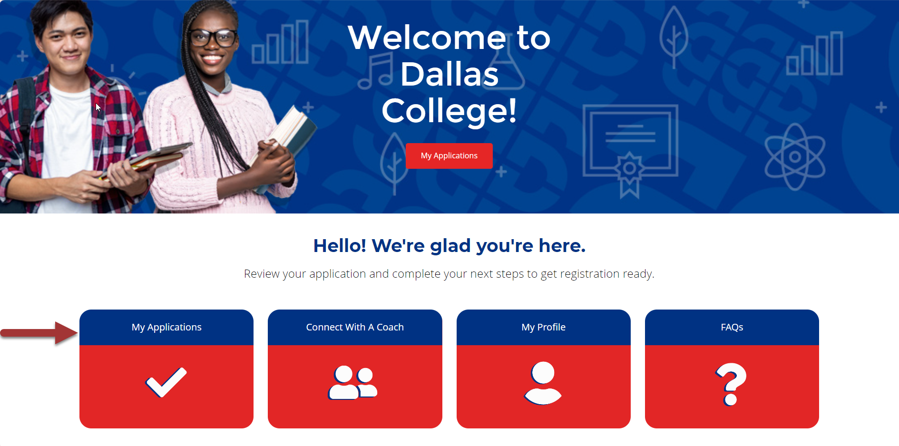
STEP 9. Select the latest Nursing Application
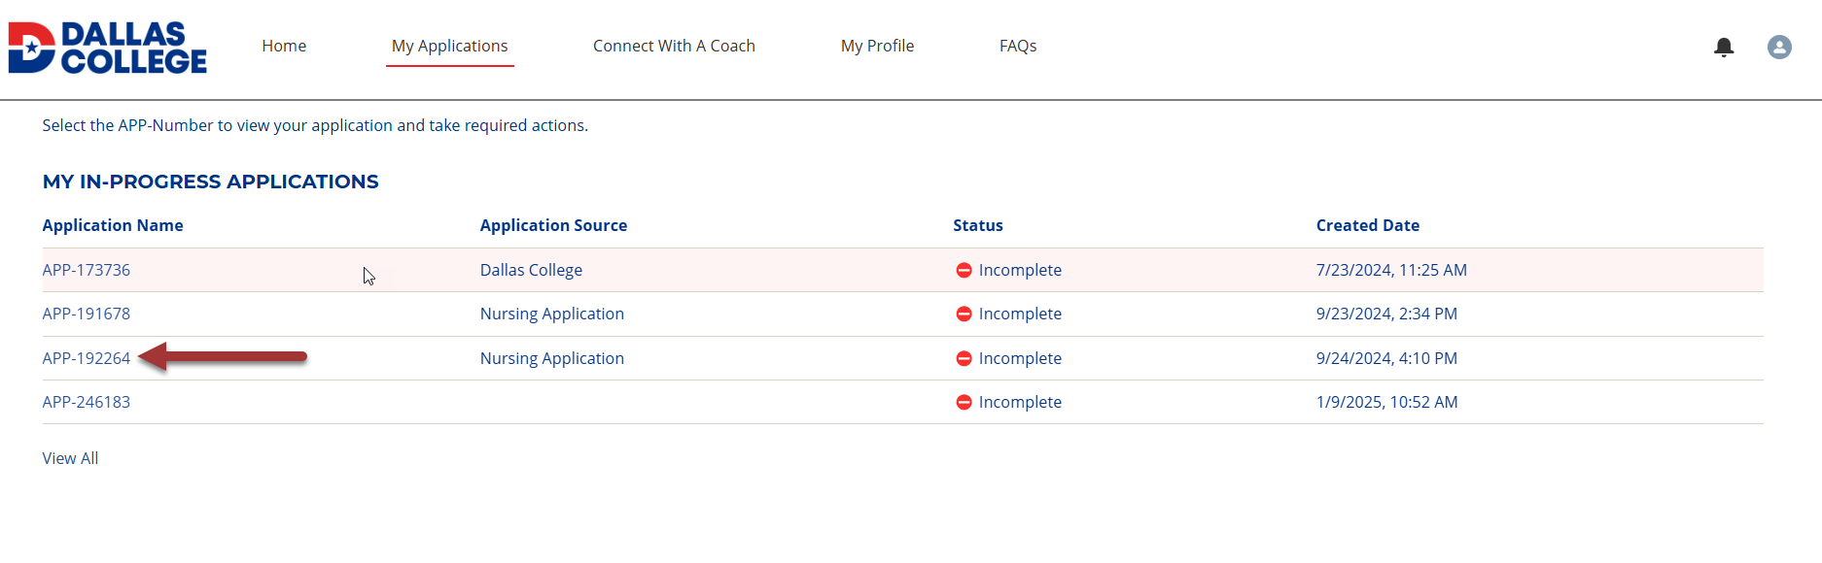
The page will open showing the students Nursing checklist items under Courses and Test Scores, and Nursing Documents.
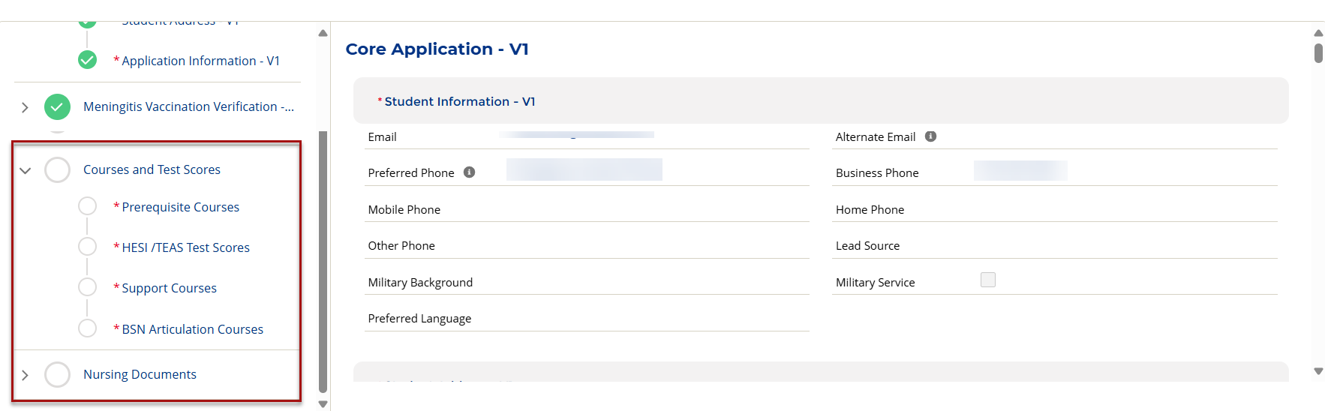
The percentage at the top of the student hub will change as the documents are reviewed. It will not be at 100% when you complete your uploads. BE PATIENT! Once you have submitted all checklist items, you will receive a confirmation that the document has been uploaded. Your record is ready to be reviewed by the Allied Health Admissions team. This may take 4-6 weeks after the submission deadline. The admissions office will contact you if additional documents are needed.

