Locating/ Entering and SAVE your Student ID Information in Evolve

- Log into your student Evolve Account HERE
- Click the ‘Account’ on upper-right corner and click on ‘Account Settings’
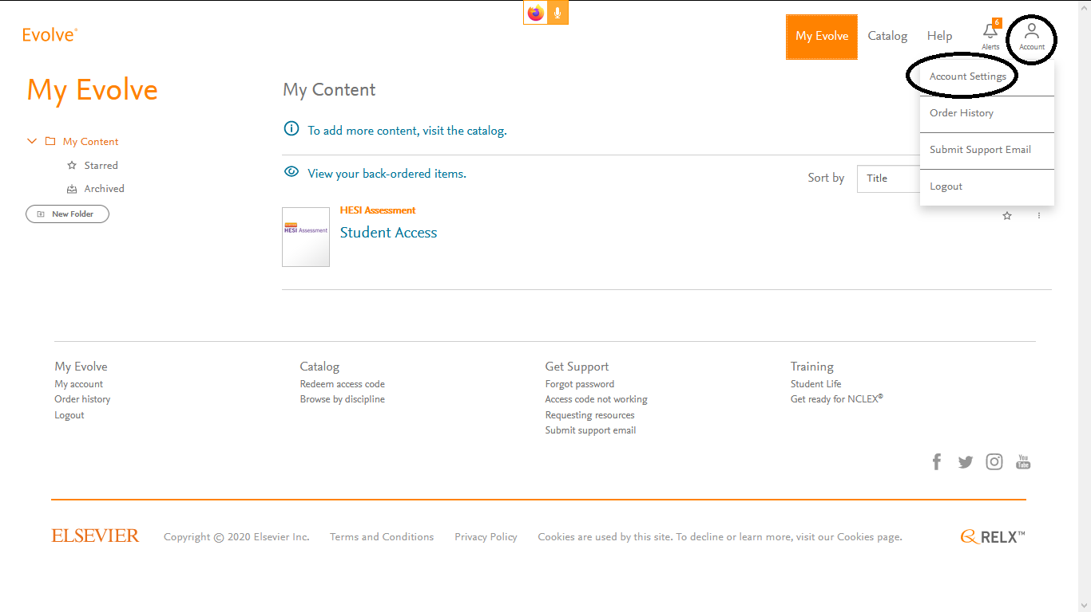
- Fill out information under ‘Institution’ and click on ‘Continue’ on bottom of page.
