HOW TO CREATE A NEW ATI ACCOUNT FOR TEAS AT INSTITUTION EXAMS
If you are not a current user on www.atitesting.com, you must create a new account to access the student portal to take your TEAS exam, complete the dry run for remote proctored online TEAS exams, access score reports following your TEAS exam, send transcripts, and much more.
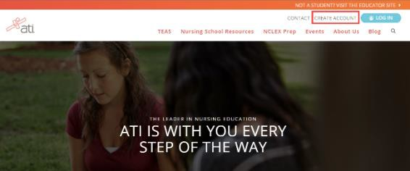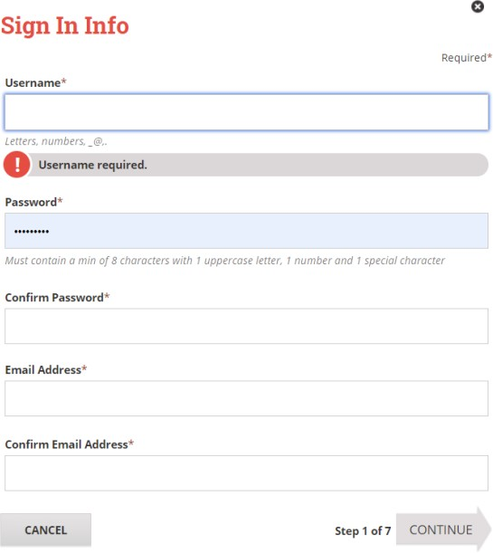
From the atitesting.com home page, click Create Account.
The Sign In Info page displays.
On the Sign In Info page, enter the account information that you will use to sign in to your account or to recover your account.

You must enter valid information into all the fields on this screen before you can proceed.

If your entry is not accepted, an error message similar to the one pictured below will display.

Reenter your information. When your entry is accepted, the message will disappear.
After you have entered all your account information, click
Continue to go to the Security Questions page.

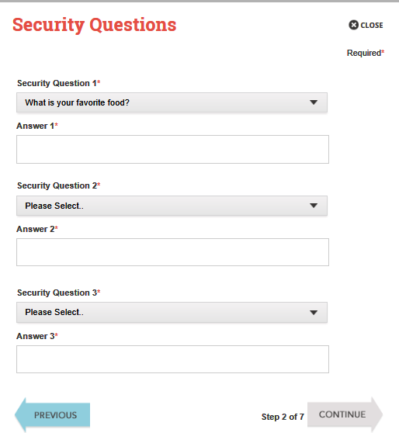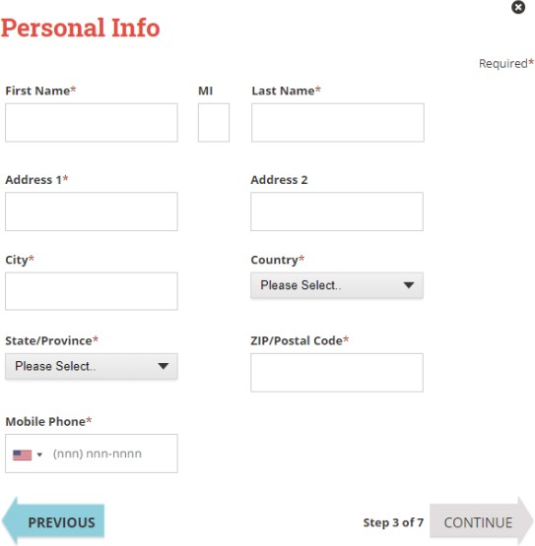
On the Personal Info page, enter your contact information. The following fields are required:
- First Name
- Last Name
- Address 1
- City
- Country
- State/Province
- ZIP/Postal Code
- Mobile Phone
Click Continue to enter your Institution information.
On the Security Questions page, select three different security questions, one from each list and enter your answer for each. Be sure to record your questions and answers for your future reference, in case you need to recover your account or you cannot remember your password.
Click Continue to enter your personal information.

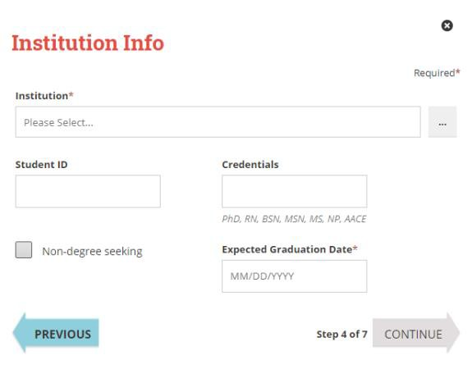
On the Institution Info page, select an Institution where you will be applying. You will need to select one main institution even if you plan to apply to more than one school. Your institution can be updated in your student account at any time. NOTE: Some schools may require you to enter your school student ID that they assign.

If you do not know your future graduation date, please click the
non-degree seeking box.
Click Continue to enter your Demographic Info.

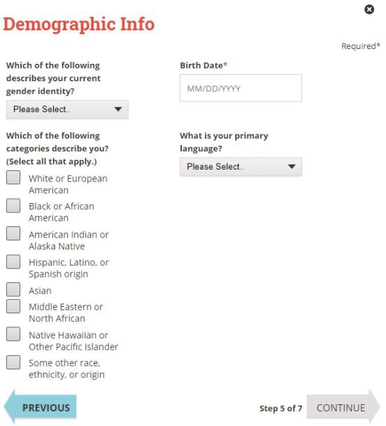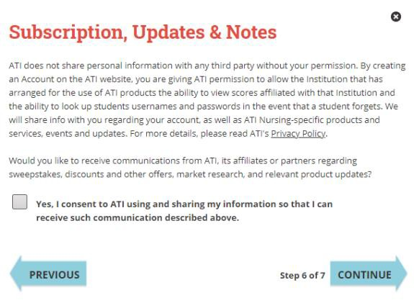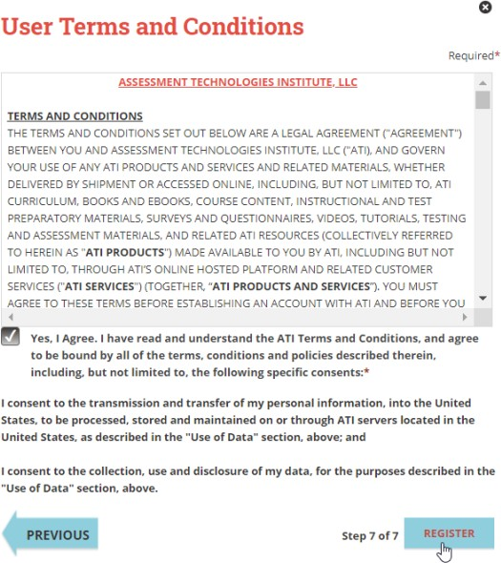
Click Register when you are finished creating your account.
Click Previous if you want to change any of the information you have entered for your new account.
On the User Terms and Conditions page, read the information under User Terms and Conditions.
Then select the Yes, I Agree check box to acknowledge that you have read the ATI User Terms and Conditions and agree to be bound by them.
On the Subscription, Updates & Notes page, read the Subscription, Updates & Notes information.

If you agree to allow ATI to share your information under the terms presented on this screen, select the Yes, I consent check box.
Click Continue to go to User Terms and Conditions.
On the Demographic Info page, enter your Gender, Birth Date, Race, and Primary Language information. Only Birth Date is required.
Click Continue to go to Subscription, Updates & Notes.

On your student home page, you can see your name in the upper right-hand corner. You can click to update any profile information here.

Click on My ATI to access your remote proctoring Dry Run to test your system
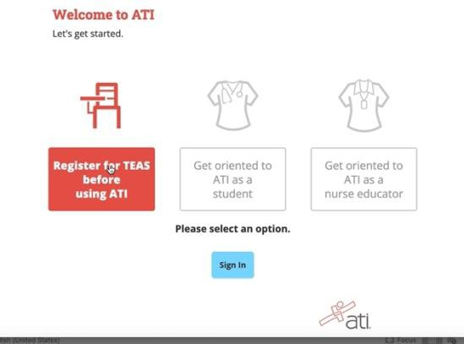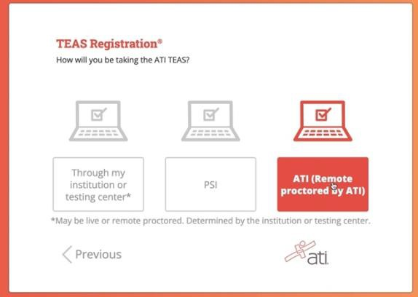
Click ATI (Remote Proctored by ATI)
The Welcome to ATI window displays.
- Click Register for TEAS to view important information About the TEAS.
- Click Sign In to go directly to the student portal. (Skip the next step.)
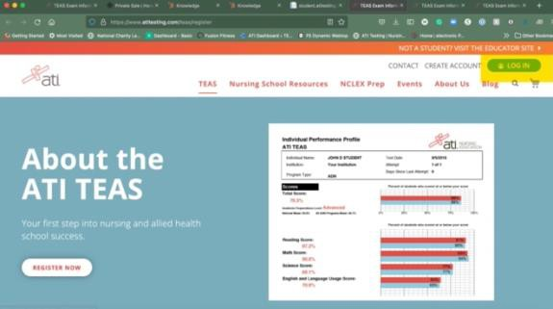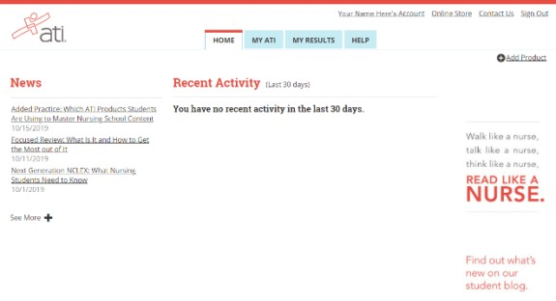
Click Sign In to get to your ATI Student Account

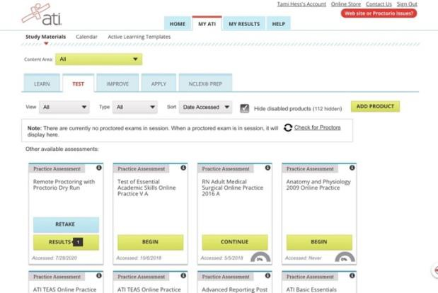
If you are taking TEAS Exam at ATI, you will want to complete the DRY RUN before exam day to make sure your system is ready to go.

NOTE – If you do not have Remote Proctoring with Proctorio Dry Run card on the Test tab, enter this Assessment ID: 17970862 Password: Demo

You will need to manually enter the assessment ID if the card doesn’t
automatically display on the Test tab.

TEAS at ATI QuickStart Guide
Follow this link for step-by-step instructions for getting started to take the TEAS at ATI exam. https://help.atitesting.com/how-to-take-a-remote-teas-at-ati-exam

Official TEAS Transcripts
Your TEAS transcript that was included in your TEAS at ATI registration will be available to send to the institution of your choice following your TEAS exam in the student portal under the MY RESULTS tab.

Go back to the top

