


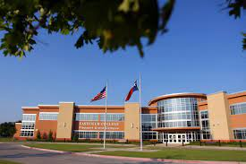


Bachelor of Science in Nursing
RN-BSN Program Information Packet

2026-2027
All information contained herein is subject to change, deletion, or modification. Approved modifications, deletions or major changes will be published as they occur.

Dear Prospective Student!
On behalf of the faculty and staff we are excited to learn you are interested in joining the Dallas College RN-BSN Nursing Program. Whether you are a Dallas College returning student, or joining our college for the first time, we are excited to have you as part of our vibrant college.
At Dallas College, we believe in the transformative power of education. Our goal is to provide you with an educational experience that equips you with the skills, knowledge, and character necessary to thrive in an ever-changing world as a nurse.
Our dedicated faculty members are experts in their respective fields and are committed to your growth. They will challenge you, inspire you, and guide you as you explore new horizons and expand your ideas. Be prepared to engage in lively discussions, think critically, and push the boundaries of your understanding.
We also believe in fostering a diverse and inclusive environment where everyone feels valued and respected. Each of you brings a unique set of experiences, perspectives, and talents to our community, and we celebrate the richness that diversity brings. In this program, you will learn from one another and build bridges of understanding and empathy that will strengthen us as individuals and as a collective community.
Once again, thank you for your interest in applying to the Dallas College RN-BSN Nursing Program. We look forward to you being a part of a community that believes in your abilities, supports your educational goals, and celebrates your successes.
We wish you the best in your future endeavors!

Sincerely,
The Administration, Faculty, and Staff at the Dallas College RN-BSN Nursing Program


Table of Contents
Program Summary and Accreditation 5
A. RN-BSN Nursing Program Application Checklist 6
B. Application Requirements to the RN-BSN Nursing Program 7
C. General Admission Requirements to the College 8
D. Previous coursework evaluation toward the RN-BSN program 10
E. Compliance Tracker 11
F. RN-BSN Application Materials Submission 11
G. Application Filing Period(s) 12
H. Admission Selection 12
I. Academic Progression Pathway 13
J. Notification of Acceptance 13
K. Curriculum Overview RN-BSN Program 13
L. RN-BSN Program General Information 15
M.Estimated Expenses for the RN-BSN 18
N. BSN-MSN Concurrent Pathway 19


RN-BSN Nursing Program

Revised for the 2026-2027 Academic Year

Program Summary and Accreditation
The Dallas College of Health Sciences offers an RN-BSN Nursing Program online. The program is designed for a Registered Nurse (RN) to complete the RN-BSN Program curriculum. The RN-BSN nursing program will focus on cultural diversity, and graduates will have the opportunity to earn a basic Spanish Interpreter certificate.

The Dallas College RN-BSN bachelor’s degree prepares the registered nurse to function in a dynamic health care community delivering safe, high quality, evidenced-based and culturally sensitive nursing care to diverse individuals, families, and populations, with an emphasis on improving health outcomes within complex healthcare systems. This foundation provides for roles in management, leadership, and potentially a basic Spanish Interpreter certificate by allowing the student, as a self-directed learner, to continue with life-long learning in an ever-changing profession.

The RN-BSN Program is approved by the Texas Board of Nursing (Address: 1801 Congress Avenue, Suite 10-200, Austin, Texas 78701; Telephone: 512-305-7400; Fax: 512-305-7401; Email: webmaster@bon.texas.gov; Website: www.bon.texas.gov). Initial Accreditation by the Accreditation Commission for Education in Nursing (Address: 3343 Peachtree Road, Suite 850, Atlanta, GA 30326; Telephone: 404-975-5000; Fax: 404-975-5020; Email: info@acenursing.org; Website: www.acenursing.org)

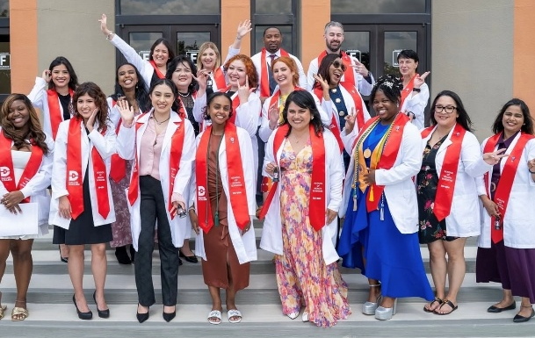

Equal Educational Opportunity
Dallas College provides educational opportunities without discrimination on the basis of race, color, religion, national origin, sex, disability, age, sexual orientation, gender identity or gender expression.

RN-BSN Nursing Program Application Checklist
This checklist is provided to assist you in following the steps toward program application. It is not a part of the application packet.
  - ____Complete an application for college admission, if not already a Dallas College student.
  - ____Submit official transcripts from all previously attended colleges/universities (to verify completion of an Association Degree in Nursing) to studenttranscripts@dallascollege.edu or to Dallas College, Attn: Admissions Processing, 3737 Motley Drive, Mesquite, TX 75150
  - ____Review RN- BSN Information Session Video
  - ____Submit RN-BSN Interest Form to receive an Educational Plan for evaluation of course work that applies to the RN-BSN Nursing Program curriculum.
  - ____Complete the Core Curriculum and lower division courses with at least a grade of “C”: Visit Catalog
  - ____Complete RN-BSN Application (with valid driver license/ government ID and Social Security card- front and back) and submit to Secure link.
  - ____Submit professional reference from Nursing Supervisor/ Manager to RNtoBSNProgram@DallasCollege.edu. ***Will take references from professor or instructor as well.
  - If you are a Dallas College 2nd, 3rd or 4th Level Student seeking Concurrent admission. Please reach out to a Senior Success Coach for the Application Checklist tailored for a Concurrent student.

Application Requirements to the RN-BSN Nursing Program
- Submit official transcripts from all colleges and universities attended to demonstrate completion of at least 90 credit hours, including a minimum GPA of 2.0.
- Evidence of a conferred Associate of Science degree in Nursing from an accredited program of nursing i.e., ACEN, NLN CNEA.
- Hold a current unencumbered license as a registered nurse in the United States. Documentation must be submitted before coursework starts.
  - An applicant waiting to take the NCLEX-RN may be conditionally admitted. Conditionally admitted applicants must pass the NCLEX before starting RN-BSN curriculum coursework.
- Evidence of coursework completion for the 42-hour lower level and Texas Core courses.
- Met the Dallas College admission standards for the RN-BSN degree program.
- Submit all completed application materials to the School of Health Science Admissions during the designated filing period.
- Students new to Dallas College are encouraged to complete the General Dallas College New Student Orientation video
- Once Accepted into the program: Submission of complete documentation of a current acceptable background check, urine drug test, physical exam, tuberculosis screening, required immunizations, proof of health insurance, and CPR certification are required to be uploaded to the programs designated compliance tracking system.
- Submit a professional reference from Nursing Supervisor, Manager, or former Professor. Email to RNtoBSNProgram@DallasCollege.edu.

Please note: Because the program will be delivered through online distance education, prospective international students will need to meet with the International Services Department to determine if they have the appropriate visa to meet SEVIS enrollment regulations.

General Admission Requirements to the College
Applicants to the RN-BSN Nursing program must meet all college admission requirements as outlined in the official college catalog and as outlined under the admission requirements.

Official College Transcripts
Prior to application to the RN-BSN Nursing program, potential applicants must have submitted official transcripts from ALL colleges and universities the applicant has attended whether the coursework is or is not relevant to the program application. Transcripts from Dallas College (formerly Dallas County Community College District) campuses are not required.
The transcripts must be current with the print date no earlier than three years prior to the
applicants anticipated admission to the program unless the student has not had a break in enrollment with Dallas College since the transcripts were originally submitted. If the official transcripts have not been submitted, the individual’s application will be voided.
Official transcripts must be sent electronically from the applicant’s previous colleges to studenttranscripts@dallascollege.edu. Transcripts sent by the applicant in pdf or other formats are not accepted. Transcripts may also be mailed from a college in a sealed envelope to Dallas College, Attn: Admissions Processing, 3737 Motley Drive, Mesquite, TX 75150.

Official transcripts must be sent to:
Dallas College
Attn: Admissions Processing
3737 Motley Drive
Mesquite, TX 75150

Electronic transcripts must be sent directly to: studenttranscripts@dallascollege.edu.

Initial Advisement
Potential students are encouraged to meet with a Senior Success Coach as a starting point toward future application to the RN-BSN program.

General Education prerequisite courses and ADN degree applicants must have an Associate degree in Nursing and complete the prerequisite courses listed below with a minimum cumulative grade point average of 2.0 or higher to apply to the RN-BSN program.
Prerequisite Courses | SCH
ENGL 1301 and Select ONE of the following: ENGL 1302, 2311, or SPCH 1311, 1315, 1321 | 6
MATH 1314 College Algebra or MATH 1342 Elementary Statistical Methods | 3
BIOL 2401 and BIOL 2402 Anatomy and Physiology I & II (lab required) | 8
Elective from Language, Philosophy, & Culture | 3
Elective from Creative Arts | 3
HIST 1301 and HIST 1302, 2301, 2328, or 2381 United States History I & II etc. | 6
GOVT 2305 and 2306 Federal Government/Texas Government | 6
PSYC 2301 General Psychology or PSYC 2314 Lifespan Growth & Development | 3
Component Area Option** | 4
RNSG 1301 Pharmacology | 3
RNSG 1311 Nursing Pathophysiology | 3
Elective- Any College Level Courses | 9
ADN Courses | Degree Conferred
***Note(s): Upon satisfying any core component area, additional course(s) or remaining credits from courses used to satisfy these component areas, may be (1) used to satisfy the 090-core component area or (2) applied as general electives to the degree plan.

Note: all program courses MUST be completed with a grade of C or better.

Previous coursework evaluation toward the RN-BSN program
Official transcripts are fully evaluated by the Dallas College Transcript Evaluation Center after a student has been enrolled for at least one regular semester. Evaluation of Previous Coursework for RN-BSN Program done by a Senior Success Coach. The Senior Success Coach will contact you within three business days of submitting the Interest Form with the next steps in your admissions process.
The School of Health Sciences and the Allied Health Admissions Office reserve the right to accept or reject any coursework completed at other colleges presented for transfer evaluation toward Health Science programs.

Five-Year Time Limit for Select Courses
The RN-BSN program does not have a 5-year time limit for ANY courses.

Credit by Examination, CLEP and Advanced Placement Credit
Credit through CLEP, High School Advanced Placement (AP) Exams, and Credit by Examination may be awarded for a limited number of courses toward Health Sciences programs including MATH 1314, PSYC 2301, and PSYC 2314. CLEP credit is not awarded for ENGL 1301.
Advanced Placement (“AP”) credit for ENGL 1301, PSYC 2301, and MATH 1314 is acceptable if the credit appears on a college transcript as ENGL 1301, PSYC 2301, and MATH 1314 equivalency. A letter grade is not awarded for “AP” credit.

Coursework from Institutions Outside of the United States
Some credits may be restricted or disallowed from colleges or universities outside the United States. International Coursework Evaluation is a multi-step process which may take several weeks. The student must be enrolled in credit classes at a Dallas College campus before the evaluation process can be initiated.

Note: An applicant must still graduate from an accredited program of nursing (The National League for Nursing Commission for Nursing Education Accreditation [NLN CNEA] or Accreditation Commission for Education in Nursing [ACEN].


Compliance Tracker
All required documentation must be submitted through the program’s designated compliance tracking system. Students will be notified of the specific system upon program entry.

Immunization Exceptions
Exceptions to immunization requirements may be granted for specific circumstances such as medical conditions, religious beliefs, or reasons of conscience. All applicants requesting an exemption must provide appropriate documentation as outlined below. Each request is reviewed individually.

- Medical Exceptions
Applicants must submit a signed statement from a physician who is familiar with their medical history. The statement must clearly explain that a particular vaccine presents a significant health risk to the applicant.

If the exemption request includes the Hepatitis B vaccine series, a separate waiver form must also be completed and submitted with the physician’s statement.

Unless the physician explicitly states that the condition is permanent, medical exemptions are valid for one year from the date of the physician’s signature. The statement must be submitted along with the Immunization Record form.

- Religious or Conscientious Objections
Applicants seeking an exemption based on religious beliefs or reasons of conscience must request an Exclusion Affidavit from the Texas Department of Health. The request can be made in writing or via electronic and include the applicant’s full name and date of birth. Requests should be mailed to:

Texas Department of Health
Bureau of Immunization and Pharmacy Support
1100 West 49th Street
Austin, Texas 78756
or electronically
https://co-request.dshs.texas.gov/

Once received, the affidavit must be completed, signed, and include the reason for the exemption. The affidavit is valid for two years and must be submitted with the applicant’s Immunization Record form.

RN-BSN Application Materials Submission

It is recommended for potential applicants to review the online RN-BSN Program information session or attend a virtual session where the program, application procedures, and acceptance policies are discussed in detail. Please note that the online information session must be viewed as a running PowerPoint.


Application Filing Period(s)
There are three official filing periods per calendar year for entry into the RN-BSN program:
- Spring 2027 Semester Due By: October 30th
  - Notification emails sent on or after November 20^{th.}
- Summer 2027 Semester: April 2nd
    - Notification emails sent on or after April 16th
- Fall 2027 Semester Due By: June 25^{th.}
  - Notification emails sent on or after July 2nd
Please refer to the Dallas College Academic Calendar.

Applicants to the RN-BSN Program must meet all college admission requirements as outlined in the official college catalog.

Admission Selection
The program spaces are filled with qualified applicants. Candidates who have satisfied all program entry requirements are admitted. Qualified applicants must have:
Application Item to submit | Location to submit Item
Completed RN-BSN application | Allied Health Admissions via the secure link
Submission of all college transcripts to demonstrate completion of at least 90 credit hours, including:  Minimum GPA of 2.0  Evidence of a conferred Associate Degree in Nursing from an nursing accredited program (i.e., ACEN, NLN CNEA)  Evidence of completion of the 42-hour Texas Core Curriculum | studenttranscripts@dallascollege.edu or to  Dallas College  ATTN: Admissions Processing  3737 Motley Drive  Mesquite, Texas 75150
Unencumbered registered nurse (RN) license in the United States | Programs Designated Compliance Tracking System
Professional reference from Nursing Supervisor/Manager ***Will take reference from professor or instructor as well. | RNtoBSNProgram@DallasCollege.edu
Upon admission:  Submission of an acceptable urine drug test  Submission of an acceptable background check  Submission of current physical exam  Submission of an acceptable tuberculosis screening  Submission of required immunization records  Proof of health insurance  Proof of current CPR certification | Designated Compliance Tracker.  Student will be notified of the specific system upon program entry.

Academic Progression Pathway
To participate in the pathway, students must:

- Be enrolled in the 2nd, 3rd, or 4th semester of the Dallas College ADN program and remain in good academic standing.

- Maintain a minimum 2.0 GPA in ADN nursing courses.

- Complete all BSN prerequisite courses (be core complete before admitted).

- Sign the Academic Progression Pathway Enrollment Agreement acknowledging program expectations and requirements.

    - Important Notes
      - Participation in the pathway is voluntary.

      - Enrollment may be limited based on program capacity.

      - Students who no longer meet eligibility requirements may be required to pause or withdraw from BSN coursework until ADN completion and RN licensure.

Notification of Acceptance
Individuals who receive an acceptance email are required to return a confirmation to verify their space in the class. Failure to return the confirmation by the date specified in the email will result in forfeiture of their space in the program. Notification emails of acceptance, non-acceptance, or disqualification are sent accordingly.
The RN-BSN Program recognizes three categories of admission: Full Admission, Conditional Admission, and Deferred Admission. Please refer to the RN-BSN Handbook for further details on admission categories.

Curriculum Overview RN-BSN Program
The Dallas College RN-BSN Program is a 120-credit hour curriculum comprised of three components: core curriculum courses (general education), lower division courses (primarily associate degree in nursing courses), and upper division BSN courses. To be admitted into the RN-BSN program an applicant must complete all core curriculum (general education) and lower division courses (Associate Degree in Nursing courses). Full-time students admitted to the RN-BSN program can complete the program in 12 months, while part-time students can finish in 24 months.

Prerequisite Courses
ENGL 1301 and Select ONE of the following: ENGL 1302, 2311, or SPCH 1311, 1315, 1321
MATH 1314 College Algebra or MATH 1342 Elementary Statistical Methods
BIOL 2401 and BIOL 2402 Anatomy and Physiology I & II (lab required)
Elective from Language, Philosophy, & Culture
Elective from Creative Arts
HIST 1301 and HIST 1302, 2301, 2328, or 2381 United States History I & II etc.
GOVT 2305 and 2306 Federal Government/Texas Government
PSYC 2301 General Psychology or PSYC 2314 Lifespan Growth & Development
Component Area Option***
RNSG 1301 Pharmacology
RNSG 1311 Nursing Pathophysiology
Elective- Any 9 College Level Hours
ADN Courses
***Note(s): Upon satisfying any core component area, additional course(s) or remaining credits from courses used to satisfy these component areas, maybe (1) used to satisfy the 090-core component area or (2) applied as general electives to the degree plan.
FULL Time: Two courses taken at a time.
PART Time: One Course taken at a time.
Courses- offered Every 8 Weeks | Credit Hours
NURS 3301 Health Assessment for the RN | 3 (2 Lecture/ 3 Lab)
NURS 3315 Transition to BSN | 3 (3 Lecture/ 0 Lab)
NURS 3324 Nursing Research | 3 (3 Lecture/ 0 Lab)
NURS 3340 Population-Focused Community Health I/Clinical | 3 (2 Lecture/ 4 Lab)
NURS 3354 Legal and Ethical Issues in Health Care I | 3 (3 Lecture/ 0 Lab)
NURS 4314 Theoretical Principles of Nursing | 3 (3 Lecture/ 0 Lab)
NURS 4323 Healthcare Organization and Informatics | 3 (3 Lecture/ 0 Lab)
NURS 4358 Public and Global Health Policy | 3 (3 Lecture/ 0 Lab)
NURS 4235 Health Care Quality | 2 (2 Lecture/ 0 Lab)
NURS 4465 Leadership and Management/Clinical | 4 (7 Ext)



RN-BSN Program General Information
- The Dallas College RN-BSN program accepts students based on program capacity each Spring, Summer, and Fall semester.
*The School of Health Sciences reserves the right to make changes in program enrollment capacity and to determine the minimum enrollment to offer the class each semester.

- The following courses require clinical hours: NURS 3301 Health Assessment for the RN, NURS 3340 Population Focused Community Health, and NURS 4465 Leadership/Management. Students should plan accordingly and be prepared for each clinical experience.

- The clinical experience component includes:
- NURS 3301 Health Assessment for the RN consists of 32 theory and 48 clinical hours (completed virtually)
- NURS 3340 Population Focused Community Health course consists of 32 theory and 64 clinical contact hours (completed virtually)
- NURS 4465 Leadership/ Management consists of 48 theory and 64 clinical contact hours (Please note 40 clinical hours is required out in the community)
Prior to clinical experiences the student will complete a Mentor Agreement and a discussion will be initiated by the Academic Chair of the RN-BSN Program regarding possible site locations. All clinical experiences must be in a location that has an affiliation agreement with Dallas College.
The student is responsible for finding BSN/MSN prepared registered nurses (RN) at the clinical site to serve as a mentor. The course faculty has final approval regarding the location of the clinical site and the mentor. To stay in compliance with the affiliation agreement, documentation must be provided before the clinical experience begins showing that the student has completed the following: American Heart Association BLS or ACLS, drug screen, immunizations, physical exam, TB testing, and health insurance.

- CPR Requirements: Applicants to the RN-BSN Program must submit American Heart Association BLS or ACLS, drug screen, immunizations, and health insurance documentation uploaded to the programs designated compliance tracking system.
Download more information at Immunization Requirements.
The specific immunizations and screenings are indicated on the health form.
Note: Additional proof of immunizations including titers may be required by hospital clinical experience sites.

All applicants must hold current certification in Basic Life Support (BLS) or Advanced Cardiac Life Support (ACLS) from one of the following approved providers:
- American Heart Association (AHA)
- American Red Cross
- Military-approved mechanism
Only face-to-face or hybrid training courses are acceptable. Online-only courses will not be accepted.
Applicants must submit a photocopy of both the front and back of the certification card to the program’s designated compliance tracking system. Students will be notified of the specific system upon entry.
The CPR certification:
- Must be valid on the anticipated program start date.
- Must not expire during any semester of enrollment in the program.
Approved CPR classes are offered at each Dallas College campus, through the American Heart Association, various hospitals, and independent instructors.
- Personal Insurance: Proof of current personal healthcare insurance coverage is required for all health sciences students. Proof of coverage must be submitted by the first day of the semester of NURS 4465. Students must secure their own coverage, and the insurance policy must cover the students at any hospital facility. Information on college student policies and rates can be found at https://www.healthcare.gov/. The National Student Nurses’ Association also partners with United Healthcare, which offers a student policy for their members. See the following link for more information: http://augeobenefits.com/nsna/home.php.

- Taking Prerequisite: Many of the RN-BSN Program Prerequisite Courses are offered online. It is recommended to complete the prerequisites in the 5-week or 8-week session, as this will allow you to get on the journey to begin the RN-BSN upper division courses sooner. Review Getting Ready for Online Learning.

- Drug Screening. All students enrolled in a health sciences program are required by the Dallas/Fort Worth Hospital Council member facilities to undergo a Criminal Background Check and Drug Screen prior to beginning their clinical experience. Students are responsible for all fees incurred for these screenings. Actual costs may vary. This procedure is conducted after a student has been accepted to the RN-BSN Program.
Results of these screenings are forwarded to the School of Health Sciences for review and verification that a student is eligible to attend clinical experiences. All background check and drug screening results become the property of the School of Health Sciences and will not be released to the student or any other third party.
A clinical affiliate/facility reserves the right to remove a student from the facility for suspicion of substance use or abuse including alcohol. The clinical affiliate/facility reserves the right to request that a student submit to a repeat drug screening at the student’s expense on the same day that the student is removed from the clinical facility. Failure to comply will result in the student’s immediate expulsion from the clinical facility. Furthermore, regardless of testing or testing results, a clinical affiliate/facility reserves the right to expel a student from their facility.
Note: Students accepted into a Health Sciences program who are unable to participate in required clinical experiences due to the results of a criminal background check and/or drug screening may be subject to dismissal from the program.

- Students are responsible for their own transportation arrangements to the college and their assigned facilities for clinical experience.

- Financial Aid: Students should apply for financial aid well in advance of program application.

- For assistance, please contact us using: RNtoBSNProgram@dallascollege.edu

Clinical Experience

For the NURS 4465 Leadership/Management course, hospital managers, and nurse administrators at a student’s place of employment (or a Dallas College affiliated organization/facility) will serve as a mentor to the student. The mentor and student will work one-on-one to meet the students’ objectives and goals for the course assignments. It is the student’s responsibility to find a mentor and have the mentor sign an agreement. The students must agree on the leadership or management topic to explore, and then the student will get approval from the student course faculty and the mentor.

The RN-BSN curriculum encourages students to seek mentors at their place of employment for their RN-BSN leadership/ management course. However, if a RN-BSN student is not currently working, Dallas College has identified community leaders that have indicated they will support these students by providing a mentor in their facility.

Estimated Expenses for the RN-BSN

 | Dallas County Resident | Out of County Texas Resident | Out of State/  Country Resident
Prerequisite Tuition/Textbooks* (30 credit. hrs.) | $2,970.00 | $5,070.00 | $7,500.00
CPR Certification** | 65.00 | 65.00 | 65.00
ELNEC Undergraduate/ New Graduate ** | 29.00 | 29.00 | 29.00
Clifton Strengths for Students (Gallup) | 24.99 | 24.99 | 24.99
Program Designated Compliance Tracking System  Physical Exam and Immunizations** | 39.99 | 39.99 | 39.99
Program Designated Compliance Tracking System  Background Check, Drug Test & Compliance Tracker** | 140.99 | 140.99 | 140.99
Total | $3,269.97 | $5,369.97 | $7,799.97
Semester I
Tuition/Textbooks* (12 credit hours) | 1,188.00 | 2,028.00 | 3,000.00
Total | $ 1,188.00 | $ 2,028.00 | $ 3,000.00
Semester II
Tuition/ Textbooks* (6 credit hours) | 594.00 | 1,014.00 | 1,500.00
Total | $ 594.00 | $ 1,014.00 | $ 1,500.00
Semester III
Tuition/ Textbooks* (12 credit hours) | 1,188.00 | 2,028.00 | 3,000.00
Total | $ 1,188.00 | $ 2,028.00 | $ 3,000.00
 | $ 6,239.97 | $ 10,439.97 | $ 15,299.97


*Tuition now includes textbook costs. These and other fees are subject to change. Tuition Calculator

See the official catalog for tuition table. A Tuition Payment Plan option is available in fall and spring semesters.

**Estimated costs
Other costs to consider: Personal health care insurance coverage, transportation, and parking for clinical experience sites.

BSN-MSN Concurrent Pathway

1. What is the BSN to MSN Concurrent Pathway with ACE?

This program allows Dallas College BSN students to begin taking graduate-level nursing courses through the American College of Education (ACE) while completing their BSN. It creates a seamless and affordable pathway to earn your Master of Science in Nursing (MSN).

________________________________________

2. When can current, students begin the concurrent program?

Students may begin the concurrent MSN pathway after completing NURS 3301 and NURS 3315.

________________________________________

3. How many credits will apply toward my MSN degree?

Six (6) credit hours taken in the BSN program will be applied toward your MSN, which reduces the total MSN credit requirement to 25 credit hours.

________________________________________

4. How many MSN courses can I take while completing my BSN?

Students may take up to 12 credit hours of MSN courses concurrently with their BSN coursework.

________________________________________

5. Can Dallas College graduates take advantage of this pathway?

Yes! Even if you have already graduated from Dallas College with your BSN, you are still eligible to take advantage of this BSN to MSN opportunity through ACE.

________________________________________

6. What are the benefits of this pathway?

• Save time by starting MSN courses while completing your BSN

• Save money with 6 credits applied directly toward the MSN

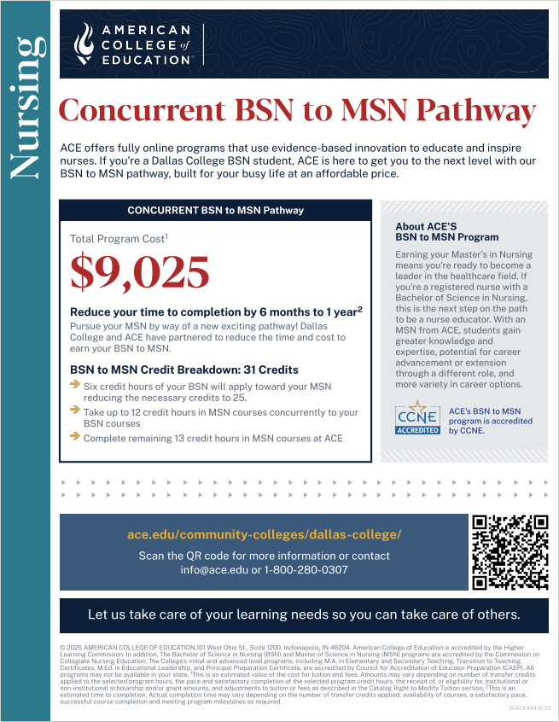
• Flexible, online coursework through ACE designed for working nurses

• Seamless transition into graduate-level study

________________________________________

7. Who can I contact for more information?

Please reach out to Senior Success Coaches for details on eligibility, application steps, and advising.

This information packet contains specific application guidelines and requirements.
Submission of application materials verifies that an individual has:
1) read the packet thoroughly,
2) obtained all necessary documents from designated website addresses, and
3) understand the policies and procedures for application and acceptance to the program.

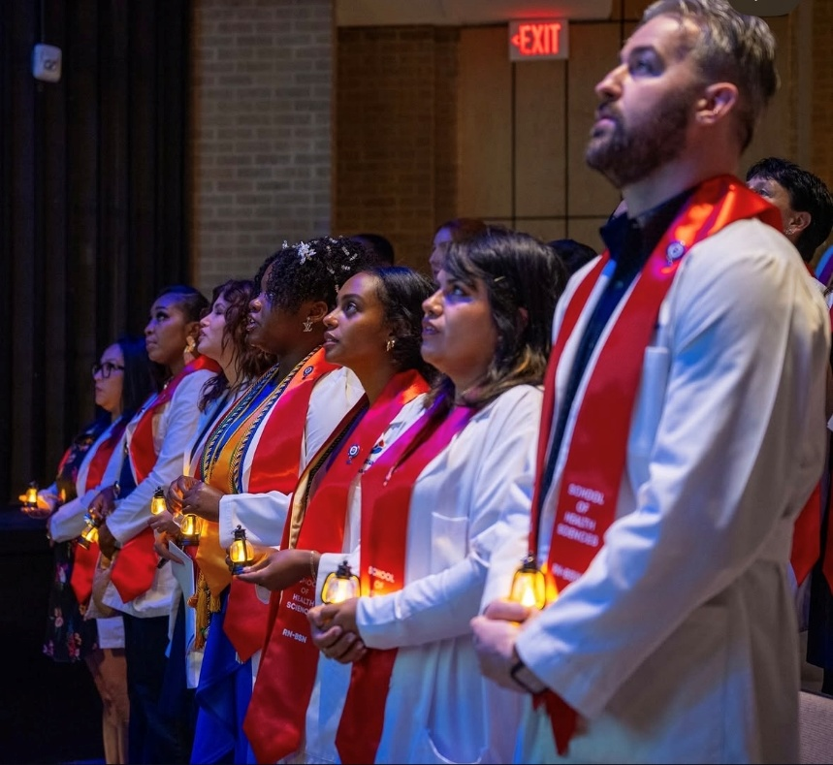
Visit the RN-BSN Program webpage.

Like us on Facebook.

Equal Educational Opportunity
Educational opportunities are offered by Dallas College without regard to race, color, religion, national origin, sex, disability, age, sexual orientation, gender identity, or gender expression.

