

Invasive Cardiovascular Technologist

Application Materials Submission-2 Step Process

Read the Following Instructions Carefully. After completing the Invasive Cardiovascular Technology Prerequisite Courses, the five designated sections of the HESI A2 test, and uploading the required physical exam, immunization, and CPR (cardiopulmonary resuscitation) certification documentation to SurPath, the applicant is ready to submit their application materials.

Step 1: Request access to the Secure Link by completing the online Secure Link Request Form.

Step 2: Use the depiction below as a reference on how to use the Secure Link. The application materials must be scanned as pdf documents. Although the line states to enter first name and then last name, please enter your last name in the first name space and enter your first name in the last name space for alphabetical purposes.
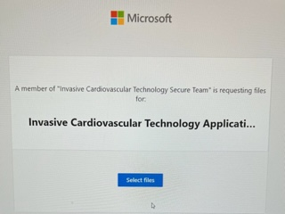
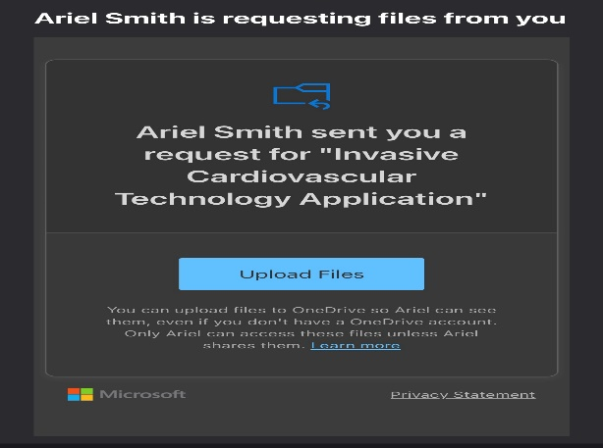

Click the “Upload Files” link; Select “Add more files” attach your PDF application materials; Input your name information and click “Upload.”
Applicants will receive an email from an Allied Health Admissions Specialist requesting the applicant “Upload Files”.

Submitting incomplete materials will disqualify the applicant. Application materials are not accepted in-person, email, or mailed by conventional mail.

Invasive Cardiovascular Technologist

Application Materials Submission-2 Step Process

Upload the following required application materials to the secure link before the filing deadline to be considered a complete and valid applicant:

- Download to complete the linked form: Invasive Cardiovascular Application and Statement of Students’ Responsibility.

- Submit a photocopy of the HESI A2 admissions exam that indicates a minimum score of 70% on each of the five required sections of the exam.

- Create a SurPath Account to upload immunization records, physical exam report, etc. prior to the application filing deadline.

- Obtain a Basic Life Support CPR w/AED certification. CPR classes are available through the Dallas College Continuing Education Division (course number EMSP 1019), the American Heart Association, various hospitals, independent instructors, etc.

- Photocopy of educational plans, request for course substitution forms, etc. if applicable.

- Photocopy of your official Phi Theta Kappa membership card/certificate (if applicable).

Note: Applicants are solely responsible for ensuring that their current official transcripts from ALL PREVIOUSLY ATTENDED COLLEGES AND UNIVERSITIES (excluding Dallas Colleges) are submitted to studenttranscripts@DallasCollege.edu or to Dallas College, Attention: Admissions Processing, 3737 Motley Drive, Mesquite, TX 75150 prior to applying to a Dallas College health sciences program. Official transcripts must have a print date no earlier than three years of anticipated entry to a health sciences program.

Submitting incomplete materials will disqualify the applicant. Application materials are not accepted in-person, email, or mailed by conventional mail.

