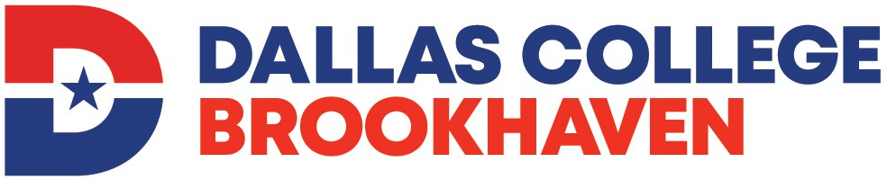

Medical Coder Certificate Program

Medical Coder Certificate Program Application

STUDENT ID NO.

NAME
Last First MI Maiden/Other

ADDRESS
Number and Street Apartment Number

City State Zip Code

PHONE
Home Cell/Other

EMAIL

HIGH SCHOOL GRADUATE? Yes No GED: Yes No

List all previous colleges attended for academic credit, including Dallas County Community Colleges.
(Current official transcripts must be on file in the Registrar’s Office.)

I am submitting my application materials for admission to the: 20 semester.
(Fall, Summer, or Spring)

STATEMENT OF STUDENTS’ RESPONSIBILITY

I have read and understand the admission process for the Medical Coder Certificate Program.

I understand that the packet is for information purposes only and does not constitute a contract, expressed or implied, between any applicant, student, or faculty member and Dallas College.

I understand that the purpose of this program is to prepare me with the skills needed to work in entry-level coding positions in a variety of healthcare settings as well as to provide a foundation to take the national certification exams to become a certified medical coder. The Medical Coder Certificate program does not guarantee job placement in hospitals, medical offices, or insurance claims offices. Additionally, the program does not prepare students for starting a home/office coding business.

I certify that the information given on this application is complete and accurate.

____________________________________________________________ ________________________
Applicant’s Signature Date

Educational and employment opportunities are offered by Dallas College without regard to race, color, age, national origin, religion, sex, disability, or sexual orientation.

