Respiratory Care Application Instructions Packet

Before applying to the Dallas College’s Respiratory Care Program, one must:

- Read the current Program Information Packet
- Watch and Listen to the Updated Program Information Session
- Request access to the Secure Link by completing the online Secure Link Request Form.

Use the depiction below as a reference on how to use the Secure Link. The application materials must be scanned as pdf documents.
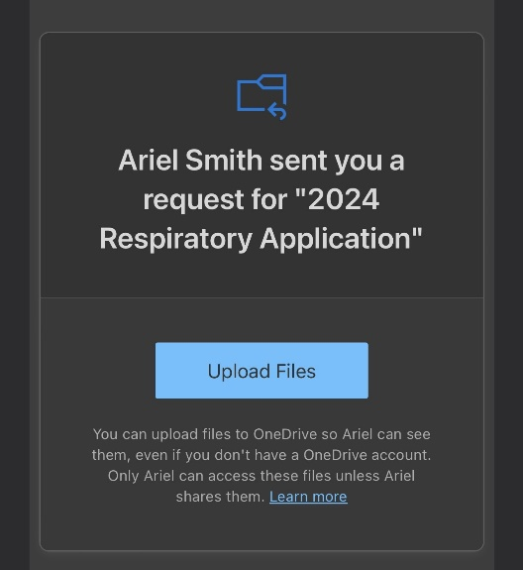

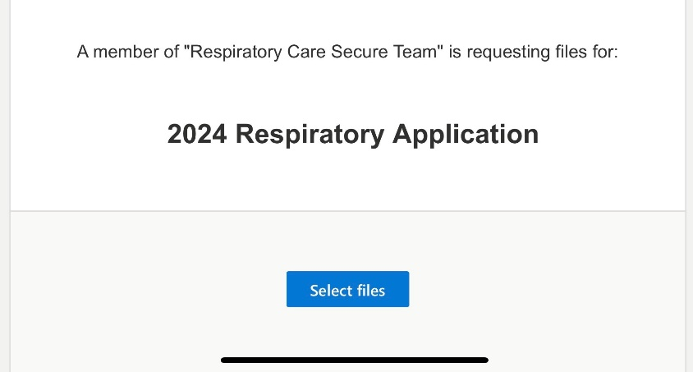

Click the “Upload Files” link; Select “Add more files” attach your PDF application materials; Input your name information and click “Upload.”
Applicants will receive an email from an Allied Health Admissions Specialist requesting the applicant “Upload Files”.

APPLY FOR SUMMER 2025 RESPIRATORY CARE PROGRAM

Follow the instructions for sending application documentation carefully. Complete application materials must be uploaded to the secure link by the application filing deadline. Application materials are not accepted in person, by email or by conventional mail.
The official application filing period for the June 2025 class of the Respiratory Care program:
January 1, 2025- April 4, 2025.
STUDENTS WHO ARE CURRENTLY ENROLLED IN PREREQUISITE COURSES ARE ELIGIBLE TO APPLY TO THE RESPIRATORY CARE PROGRAM.
Applicants are notified via email of selection status by April 18, 2025.
The late application filing period for the Summer 2025 Respiratory Care class is:
April 7, 2025, through 12:00 noon on May 9, 2025.
NOTE: Applicants who are being offered a late space for the Summer 2025 class will be notified via email on May 16, 2025
Individuals who receive an acceptance email must return a confirmation form within a specified time to verify their space in the class. Failure to return the confirmation form by the specified date or failure to attend the scheduled preregistration/orientation seminar for the accepted class will result in forfeiture of their space in that class.

- APPLICATION:
Using the secure link to submit a completed Associate Degree Respiratory Care Program Application and signed Statement of Student’s Responsibility form.

- TRANSCRIPTS:
Transcripts are not to be sent via the secure link. All transcripts from colleges you have attended must be sent to Dallas College’s Admissions to apply to the Respiratory Care Program (even if you are not transferring credits). It is not necessary to send Dallas College transcripts.
Official transcripts from all previously attended colleges/universities to studenttranscripts@dallascollege.edu or to Dallas College, ATTN: Admissions Processing, 3737 Motley Drive, Mesquite, TX 75150

- HESI A2 EXAM:
All applicants to the Respiratory Care program must earn a minimum score of 70 of higher on the following five sections of the HESI A2 score sheet: Reading Comprehension, Grammar, Vocabulary/General Knowledge, Math, and Anatomy/Physiology. Test scores are valid for two years from the date of testing to the application filing deadline date.

- DOCUMENTATION OF APPLICATION ELIGIBILITY:
- Category 1 Applicant – Completion of the six HPRS courses will be verified on official transcripts and/or the advising report.
- Category 2 Applicant – The following documentation must be submitted with application materials: A photocopy of the Non-traditional Equivalent Credit Assessment form signed by the HPRS Coordinator and Division Dean if credit for one or more HPRS courses was awarded through the prior Learning Assessment Portfolio process or if credit was awarded through a programmatic assessment exam. If an applicant under Category 2 enrolled and completed one or more HPRS courses through traditional enrollment, the coursework will be verified on official transcripts and/or the advising report.
- Category 3 Applicant – The following documentation must be sent with application materials:
- Photocopy of a current professional healthcare credential such as a nursing license, ARRT registry, CST certification, CCIS registry, CMA certification, etc.
AND
- Official transcript or other official document authenticating the completion of the qualifying degree or certificate.

- FIVE (5) YEAR TIME LIMIT WAIVER on BIOL 2401, 2402, or 2420 (if applicable):
All science coursework must have been completed less than five years before the expected Health Sciences program start date.

5 Year Waiver Criteria
- The applicant has current work experience in a healthcare setting using their related physics knowledge.
- The applicant has successfully completed advanced courses in a related physics area with a grade of “C” or higher.

Please contact a Health Science Pathway Specialist at ASKSOHS@dallascollege.edu for additional assistance on 5 Year Time Limit Waiver Petition process.

- ANY ADDITIONAL DOCUMENTATION (if applicable):
Additional documentation of the application requirements may be submitted to the Secure Link, such as:
- Explanation of any particular application requirement to be considered as part of this application.

