Read the Following Instructions Carefully. After completing the Surgical Technologist Prerequisite Courses, the five designated sections of the HESI A2 test, and uploading the required physical exam, immunization, and CPR (cardiopulmonary resuscitation) certification documentation to SurPath, the applicant is ready to submit their application materials.

Step 1: Request access to Secure Link to upload all application documents, by emailing AlliedHealthAdmissions@dcccd.edu. The subject line of the email must be Surgical Technologist Program Application Materials.

Step 2: Use the depiction below as a reference on how to use the Secure Link. The application materials must be scanned as pdf documents. Although the line states to enter first name and then last name, please enter your last name in the first name space and your first name in the last name space for alphabetical purposes.

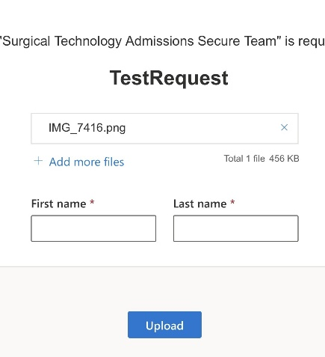
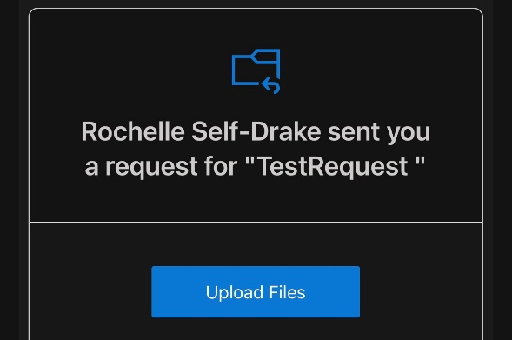

Applicants will receive an email from an Allied Health Admissions Specialist requesting the applicant “Upload Files”.
Click the “Upload Files” link; Select “Add more files” attach your PDF application materials; Input your name information and click “Upload.”

Upload the following required application materials to the secure link before the filing deadline to be considered a complete and valid applicant:
- A completed Surgical Technologist Program Application and the signed Statement of Students’ Responsibility form.
- The HESI A2 score sheet indicating achievement of a minimum score of 70% or higher on each of the five required sections and the Personality Profile and Learning Style results.
- Copies of any request for course substitution forms (for evaluated transferred courses) or 5-year waiver forms granted to the student.

Note: Applicants are solely responsible for ensuring that their current official transcripts from ALL PREVIOUSLY ATTENDED COLLEGES AND UNIVERSITIES (excluding Dallas Colleges) are submitted to studenttranscripts@DallasCollege.edu or to Dallas College, Attention: Admissions Processing, 3737 Motley Drive, Mesquite, TX 75150 prior to applying to a Dallas College health sciences program. Official transcripts must have a print date no earlier than three years of anticipated entry to a health sciences program.

Submitting incomplete application materials will disqualify the application and the student will not be considered further in the application process. Students are advised to retain a photocopy of all materials submitted as their application and to SurPath.

