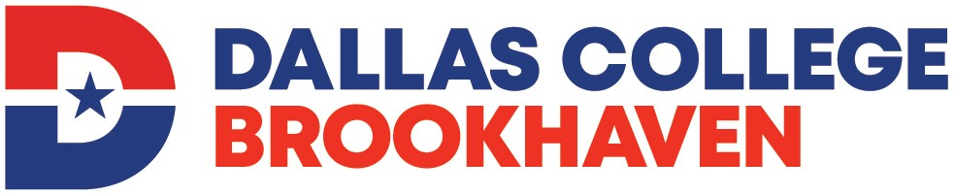

Medical Coder Certificate Program

Medical Coder Certificate Program Application

STUDENT ID NO. ______ __

NAME
Last First MI Maiden/Other

ADDRESS
Number and Street Apartment Number

City State Zip Code

PHONE
Home Cell/Other

EMAIL

HIGH SCHOOL GRADUATE? Yes No GED: Yes No

List all previous colleges attended for academic credit, including Dallas County Community Colleges.

(Current official transcripts must be on file in Registrar’s Office.)

I am submitting my application materials for admission to the: 20 semester.
(Fall, Summer or Spring)

STATEMENT OF STUDENTS’ RESPONSIBILITY

I have read and understand the admission process for the Medical Coder Certificate Program.

I understand that the packet is for information purposes only and does not constitute a contract, expressed or implied, between any applicant, student, or faculty member and Dallas College.

I understand that the purpose of this program is to prepare me with the skills needed to work in entry-level coding positions in a variety of health care settings as well to provide a foundation to take the national certification exams to become a certified medical coder. The Medical Coder Certificate program does not guarantee job placement in hospitals, medical offices, or insurance claims offices. Additionally, the program does not prepare students for starting a home/office coding business.

I certify that the information given on this application is complete and accurate.

Applicant’s Signature Date

Educational and employment opportunities are offered by Brookhaven College without regard to race, color, age, national origin, religion, sex, disability, or sexual orientation.

